pattern

#include<iostream>

using namespace std;

int main() {

int rows;

std::cout << "Enter the number of rows: ";

std::cin >> rows;

for (int i=1 ;i<=rows ;i++) {

for (int j=1 ;j<=rows-i ;j++) {

std::cout << " ";

}

for (int k=1 ;k<3\*i-1 ;k++){

std::cout << "1";

}

std::cout << std::endl;

}

return 0;

}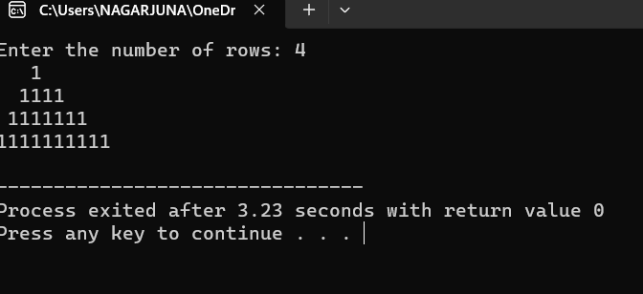

Vehicle

#include<iostream>

using namespace std;

class vehicle{

public:

char model[15],make[15];

int year;

public:

void read();

void display();

};

void vehicle::read(){

cout<<"enter the make ,model,year";

cin>>make;

cin>>model;

cin>>year;

}

void vehicle::display(){

cout<<"make:"<<make<<"\n";

cout<<"model:"<<model<<"\n";

cout<<"year:"<<year<<"\n";

}

class car :public vehicle{

public:

int passangers;

float colour;

public:

void read1();

void display1();

};

void car ::read1(){

cout<<"enter passangers ,colour";

cin>>passangers;

cin>>colour;

}

void car :: display1(){

cout<<"passangers:"<<passangers<<"\n";

cout<<"colour:"<<colour<<"\n";

}

int main(){

car c;

c.read();

c.read1();

c.display();

c.display1();

}

